Bug Id :Bug_001
Title: Adding the same User again and again .
Module :Add User
Step to Reproduce :
1.Login in to Dashboard
2.click on Add user
3. Enter the same existing user Details

Expected Result : An error message should be displayed indicating that the user is already registered.
Actual Result : User Getting Added in UI and DB
Severity : Medium
Priority: High

Proof of Document :
IN DB.json File
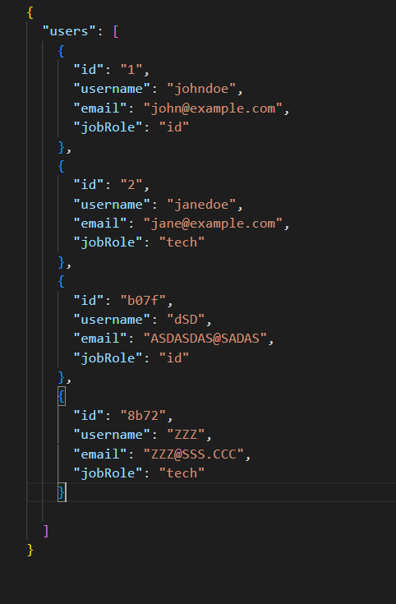
Adding user from UI
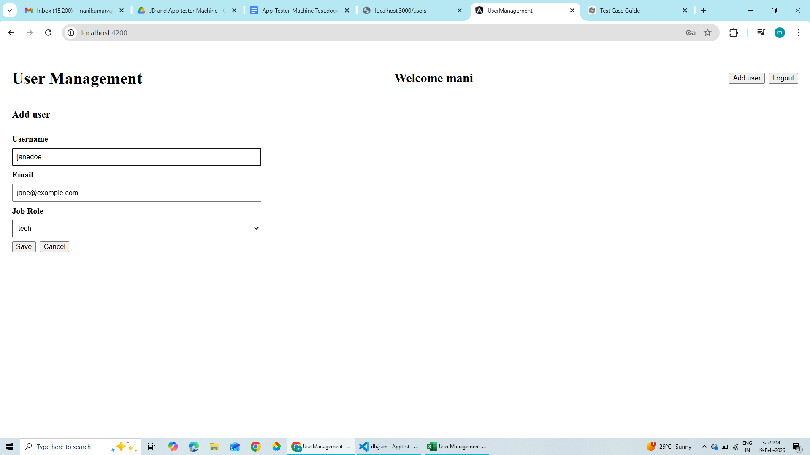
User Got added in the DB and UI
